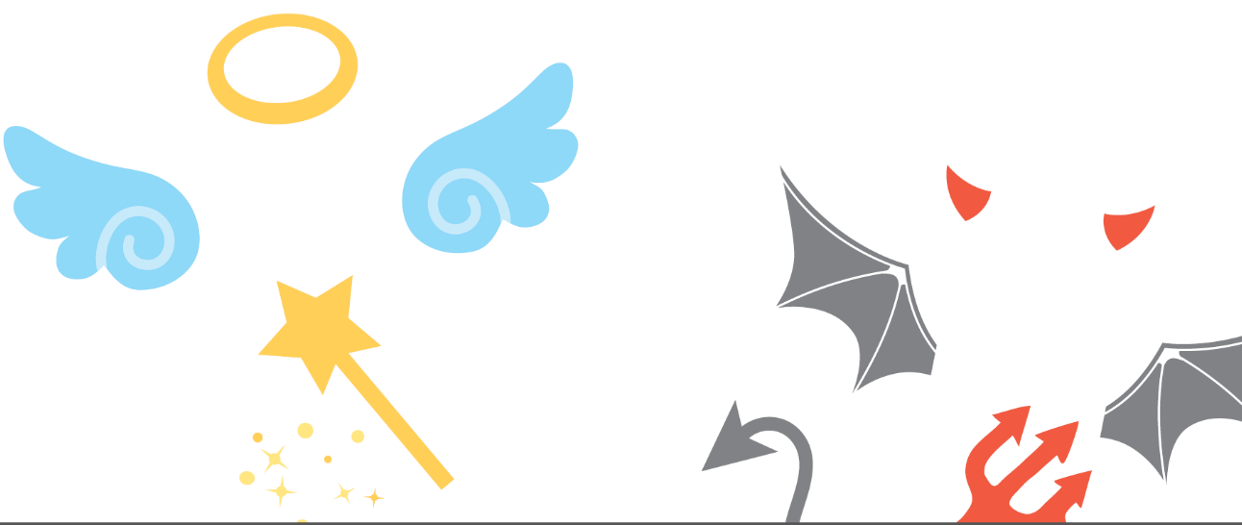
Should ethics be the biggest influence on decision-making for all businesses? Justify your answer. 16 marks

You can bring in Business examples from the only way is Ethics work previously set.
Suggested Layout –
Paragraph 1 – Yes, Ethics should be the biggest influence on decision making because ………..
Analyse point, bring in evidence to support (Business examples), evaluate point.
Paragraph 2 – No, Ethics shouldn’t be the biggest influence on decision making because ….. (What should be instead?)
Analyse point, bring in evidence to support (Business examples), evaluate point.
Paragraph 3 – Conclusion – answer the question should ethics be the biggest influence or not? Why – justify, however …….. but most importantly ……………….

____________________________________________________________________________________________________________________________________________________________________________________________________________________________________________________________________________________________________________________________________________________________________________________________________________________________________________________________________________________________________________________________________________________________________________________________________________________________________________________________________________________________________________________________________________________________________________________________________________________________________________________
__________________________________________________________________________________________________________________________________________________________________________________________________________________________________________________________________________________________________________________________________________________________________________________________________________________________
__________________________________________________________________________________________________________________________________________________________________________________________________________________________________________________________________________________________________________________________________________________________________________________________________________________________
__________________________________________________________________________________________________________________________________________________________________________________________________________________________________________________________________________________________________________________________________________________________________________________________________________________________
__________________________________________________________________________________________________________________________________________________________________________________________________________________________________________________________________________________________________________________________________________________________________________________________________________________________
__________________________________________________________________________________________________________________________________________________________________________________________________________________________________________________________________________________________________________________________________________________________________________________________________________________________
__________________________________________________________________________________________________________________________________________________________________________________________________________________________________________________________________________________________________________________________________________________________________________________________________________________________
__________________________________________________________________________________________________________________________________________________________________________________________________________________________________________________________________________________________________________________________________________________________________________________________________________________________
____________________________________________________________________________________________________________________________________________________________________

