JKHS Geography Y11 – 12 transition work CAG

Read
Tim Marshall – Prisoners of Geography: Ten maps that tell you everything you need to know about global politics. PDF copy of book on website.

Write
For each of the ten regions that are discussed in Prisoners of Geography, summarise who the main protagonists are, what prior conflict(s) have affected the region, what the current source(s) of tension are and what future conflict(s) could arise (& why)

Watch
BBC iplayer has a wealth of relevant documentaries, below is a selection that will be relevant to your A level studies over the next two years. For each one that you watch you should summarise what you see/learn on to 1 side of A4 – this could be in the form of written notes, bullet points, a mind map, its up to you (what method helps you remember material best?)
Try and use some of the synoptic themes that are contained in the exam spec:
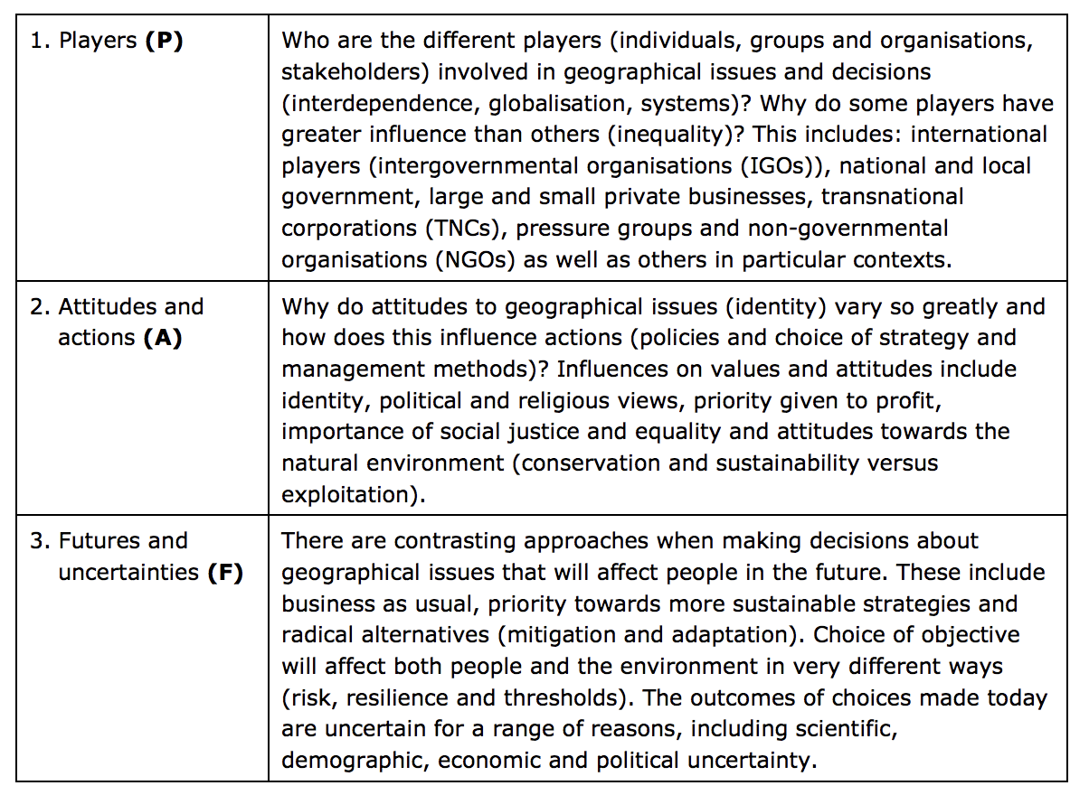
Documentaries:
China: A New World Order https://www.bbc.co.uk/iplayer/episode/m0007znv/china-a-new-world-order-series-1-episode-1
Russia: The Empire Strikes Back https://www.bbc.co.uk/iplayer/episode/m000j1s3/russia-the-empire-strikes-back-series-1-1-part-one
Simon Reeve – The Americas https://www.bbc.co.uk/iplayer/episodes/m00095p0/the-americas-with-simon-reeve
Simon Reeve – Russia https://www.bbc.co.uk/iplayer/episode/b096sc3z/russia-with-simon-reeve-series-1-episode-1

